* We cant use super keyword inside static
* Inheritance
* Abstraction

Polymorphism

* Important feature of Object Oriented Programming
* Poly 🡪 Many
* Morphism 🡪 Form
* Hence Many form
* Types:-
  1. Compile time polymorphism
     + Method Overloading
       - Used again and again
       - Method name should be same
       - Method return type, No of Arguments and types may or may not be different

1. Static methods are directly called or from class name not from object name

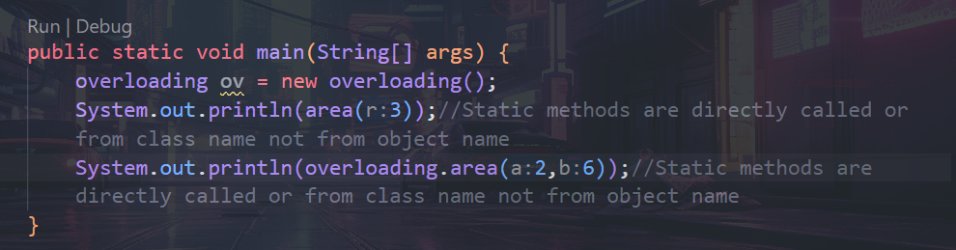

* + - Method Overriding
  1. Run Time Polymorphism

Method Overloading:-

class overloading {

    static float area(int r){

        return 3.14f*r*r;

    }

    static int area(int a,int b){

        return a*b;

    }

    public static void main(String[] args) {

        overloading ov = new overloading();

        System.out.println(area(3));//Static methods are directly called or from class name not from object name

        System.out.println(overloading.area(2,6));//Static methods are directly called or from class name not from object name

    }

}

Method Overriding

* Method name should be same.
* Method return type, No or Arguments and types of arguments should be same
* It works in Inheritance.
* Jiska object uske methods ko call.
* class overridedemo{
* void draw(int m){ //no of arguments, return type of method and type of arguments should be same
* System.out.println("Base Class draw method");
* }
* }
* class overridding extends overridedemo {//no of arguments, return type of method and type of arguments should be same
* void draw(int m){
* System.out.println("Child Class draw method");
* }


* public static void main(String[] args) {
* overridding ov = new overridding();
* ov.draw(0);
* }
* }

Final Keyword

* Final is keyword in java. When final is used within variable, method and class.
* When final is used within variable then it cannot be modified.
* When final is used within method then method cannot be overridden
* When final is used with class then class cannot be inherited.

Exception Handling in JAVA

* Exception is run time error in Program.
* Exception is an abnormal condition.
* Exception is an event that disrupts normal of program.
* Types 🡪
  + Checked Exception🡪 These are checked during compile time.
  + Unchecked Exception🡪 These are not checked during compile time.

Exception Handling Mechanism

try…catch…finally

* In “try” Block exception code is written.
* When exception is raised from try block it is caught in ‘catch’ block. It means that the catch block is responsible to handle the exception.
* “finally,” block is used to include the code in every case when the exception handled or not by the catch block
* Any one catch block is executed or else try nested try catch block

Throw vs Throws keywords in java.

|  |  |
| --- | --- |
| throw | throws |
| 1. It is used to throw an exception explicitly. 2. It is followed by object of a class. 3. It is used inside the method. 4. Throw the exception object. | * 1. It is used with method signature.   2. Multiple Exception can be thrown in method signature by throws keyword.   3. Used for throwing multiple exception after the name of the method |
|  |  |

If whole method throws exception , the it should be handled at the point from where it is called i.e. here from main method and it must be handled using try..catch.